Ideation Phase

Define the Problem Statements

Date | 15 Feb 2026
Team ID | LTVIP2026TMIDS43270
Project Name | Visualization Tool for Electric Vehicle Charge and Range Analysis
Maximum Marks | 2 Marks

Customer Problem Statement Template:
Create a problem statement to understand your customer's point of view. The Customer Problem Statement template helps you focus on what matters to create experiences people will love.
A well-defined customer problem statement helps identify stakeholder needs, technical gaps, and emotional impact. It ensures the EV dashboard is designed to solve real-world decision-making challenges.

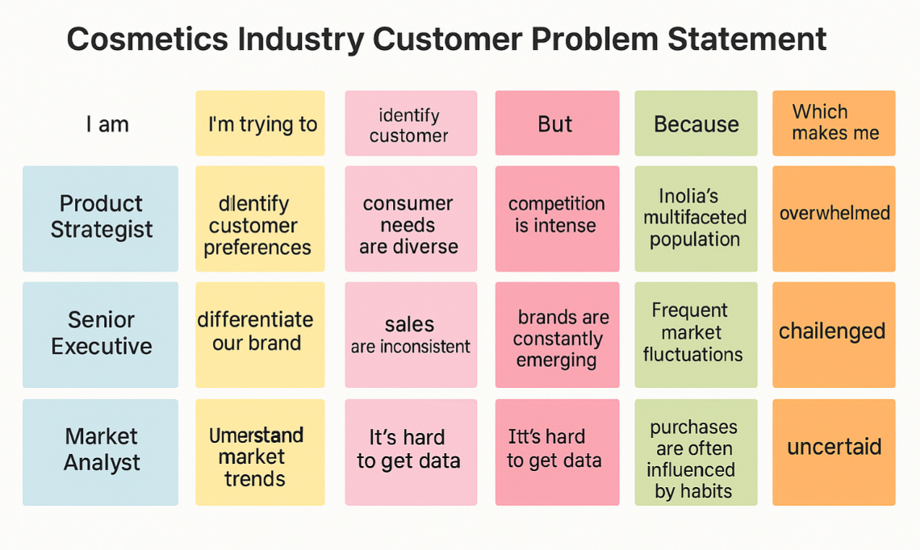

PS ID | I am | I'm trying to | But | Because | Which makes me feel
PS-1 | a fleet manager managing multiple electric vehicles | Track EV energy consumption and measure carbon emission reductions | data is scattered across telematics systems and spreadsheets | there is no unified dashboard integrating charge, range, and vehicle performance | anxious about unexpected breakdowns and operational delays
PS-2 | an individual EV owner | optimize my charging habits to improve battery life and maximize driving range | I cannot clearly see how charging frequency, speed, and environmental conditions impact my range | the data is available but not visualized in an easy-to-understand format | confused and uncertain about maintaining long-term battery health
PS-3 | a sustainability manager in a corporate organization | track EV energy consumption and measure carbon emission reductions | reports lack interactive insights and comparative analytics | existing tools do not connect environmental data with vehicle performance | unsure about presenting sustainability impact confidently to stakeholders
PS-4 | a data analyst working in the EV industry | analyze how temperature, terrain, driving speed, and load affect EV range | I cannot easily correlate multiple variables dynamically | current tools are static and do not allow interactive filtering or drill-down analysis | stuck while trying to extract meaningful patterns
PS-5 | a charging station operator | understand peak charging demand, station utilization, and customer behavior | I lack time-based and location-based visual analytics | the system does not provide predictive trends or heatmap views | overwhelmed when planning infrastructure expansion
PS-6 | a senior executive overseeing EV adoption strategy | review high-level KPIs such as average range, energy efficiency, and charging cost trends | dashboards are too technical and lack storytelling visuals | reports focus on raw data instead of strategic insights | disengaged during decision-making meetings
PS-7 | a government transportation planner | assess EV charging infrastructure performance across regions | I cannot compare urban vs rural utilization effectively | there is no geo-spatial and comparative analytics dashboard | uncertain about policy planning decisions
PS-8 | a vehicle performance engineer | monitor battery degradation and efficiency over time | long-term performance data is difficult to visualize historically | tools do not provide trend forecasting or degradation analysis | concerned about predicting maintenance needs accurately
PS-9 | a logistics company operations head | reduce operational costs related to EV charging and downtime | I cannot track energy cost trends and vehicle utilization simultaneously | data systems are disconnected and lack cost-performance integration | frustrated about optimizing fleet profitability
PS-10 | an EV startup founder | present product performance and market readiness to investors | I lack compelling visual dashboards with storytelling elements | available reports are static and not investor-friendly | unprepared during funding presentations

